Used sample-java-sdk app to create Subsciptions using below cases: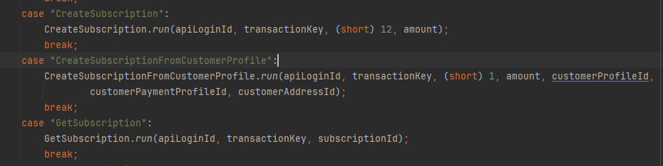

I created multiple subscriptions like, Creating Subscription and also creating Subscription from Customer Profile as well.

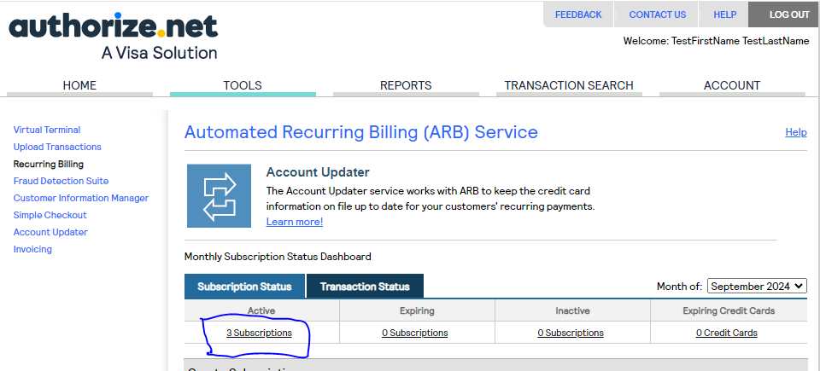

9365387 is Created from Customer Profile and other two’s are created from sample data.

Both subscription are created as starting date as 25th Sept 2024. And 12 occurrences.

Also if you see on right side both the subscription has already executed one time already without any error

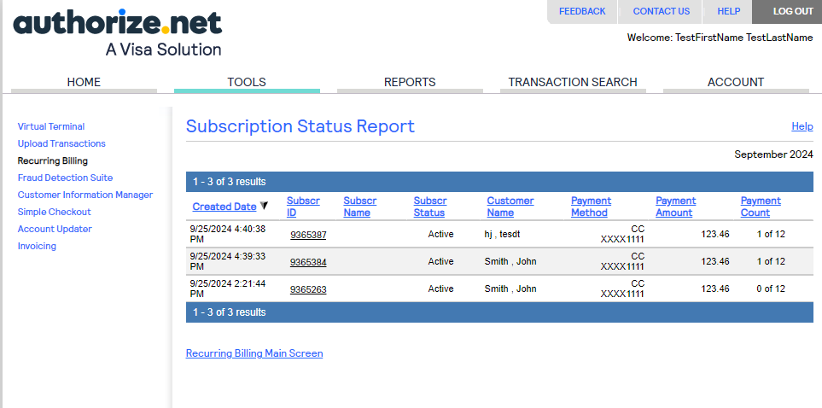

In below screenshot we can see there is completed payment.

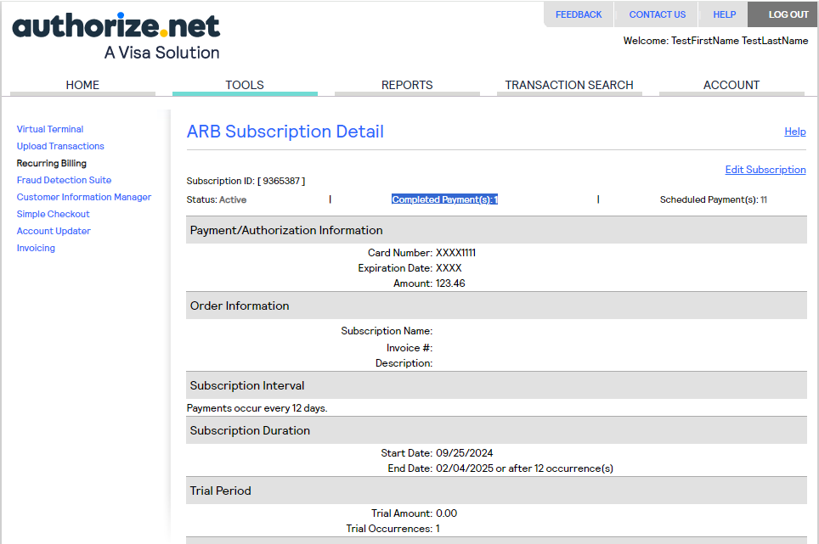

Also we get the mail for successful and failed ARBs on our mail as well, where I can see all are success only.

